Aws vpc Task-2

- Create one VPC, with 1 public subnet and 1 private subnet.
- Created on vpc and named task2
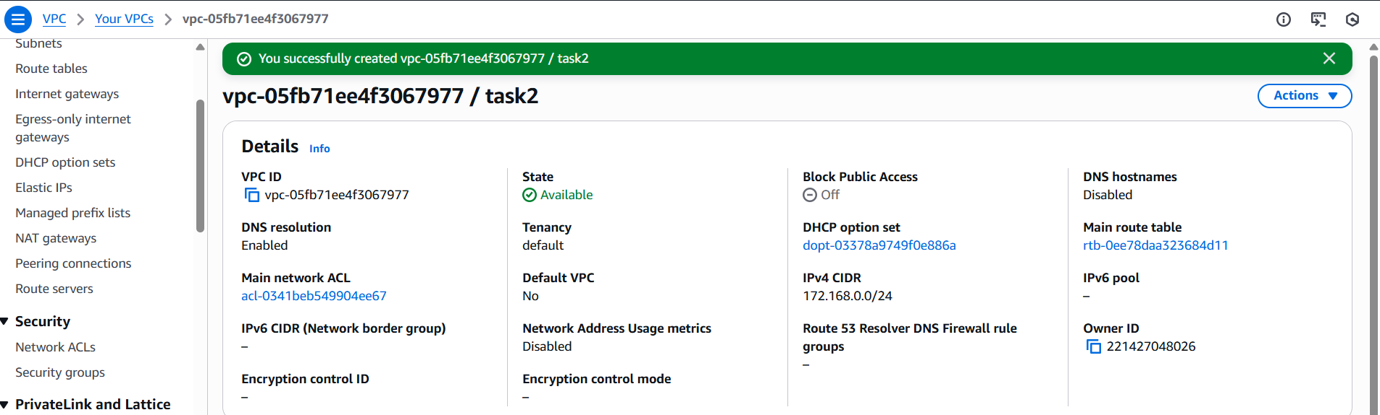
- Created one private subnet and one public subnet
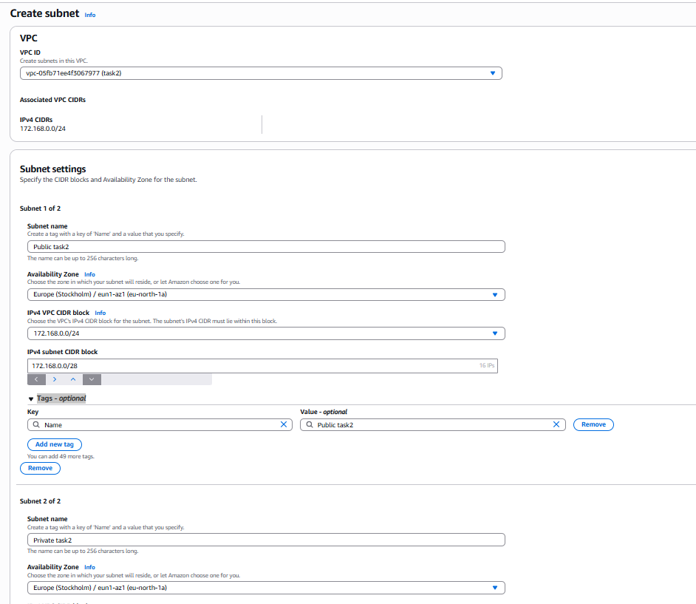
- We can see two types of subnets are created
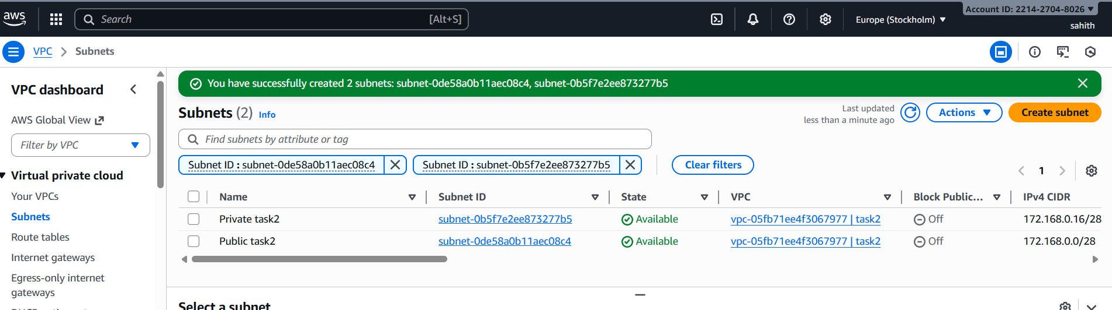
- Enable VPC peering for cross-region.
- First created vpc one in region A and another one in region B
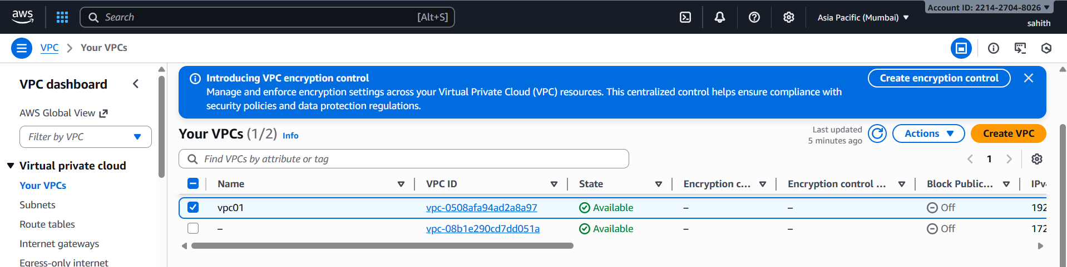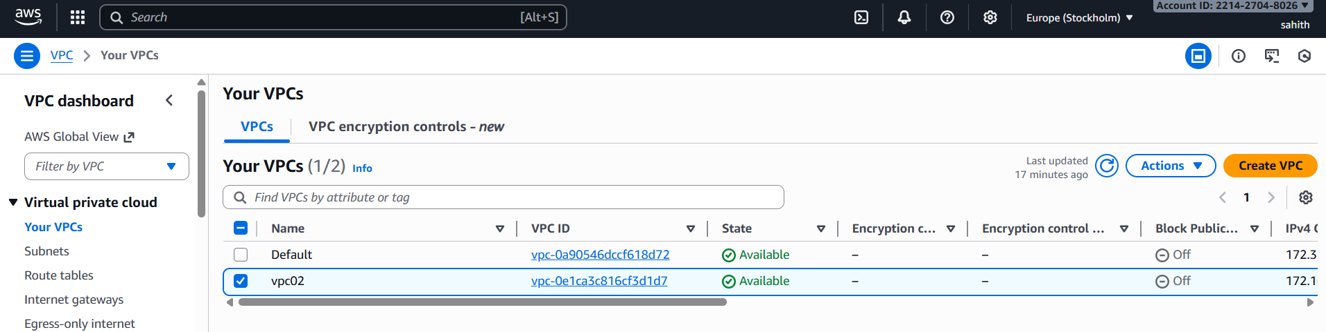
- created subnets one in region A subnet01 and another one in region B subnet02
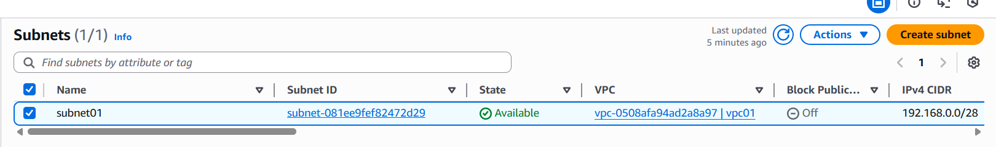
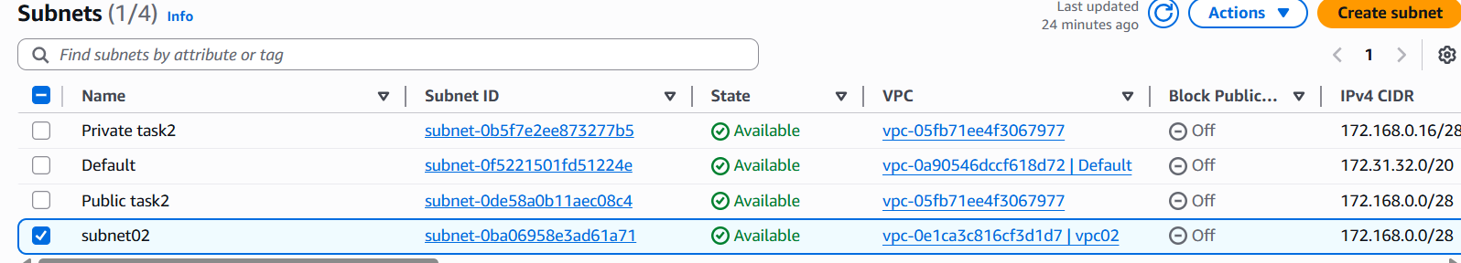
- created route tables one in region A rt01 and another one in region B rt02
- gave subnet associations permissions
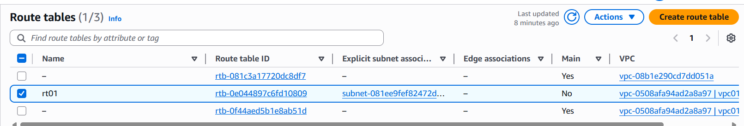
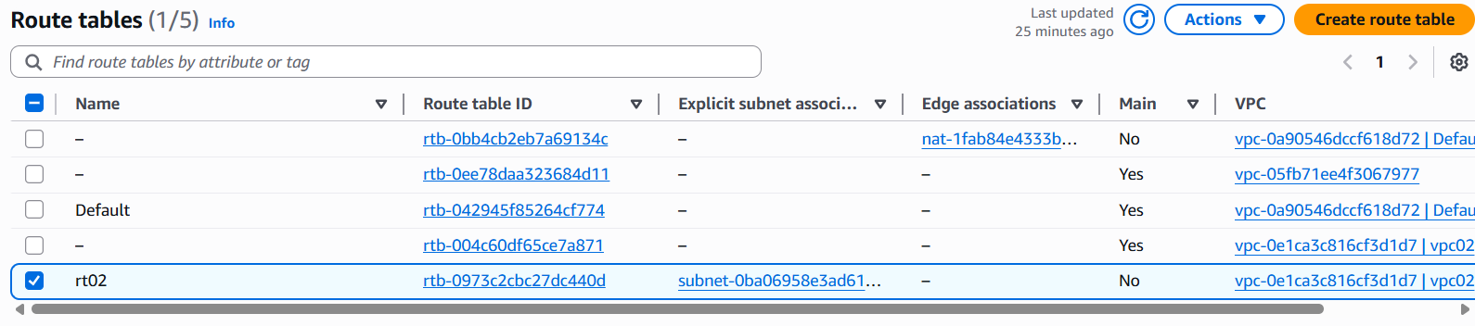
- created internet gateway myiwn01 in region A
- gave access to the route table
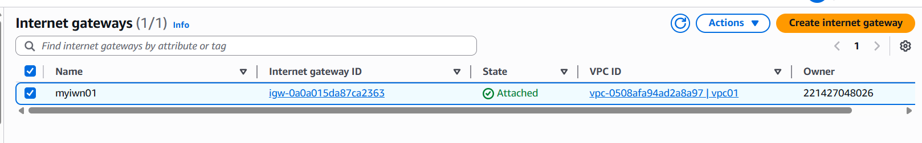
- created internet gateway igw02 in region B
- gave access to the route table
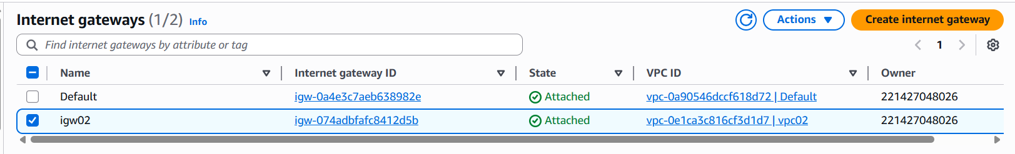
- created peering connections in region A and region B
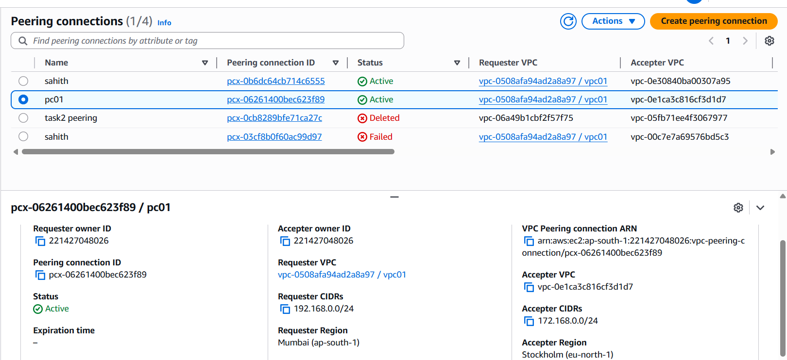
- connected them using peering connection ID
- using two different regions
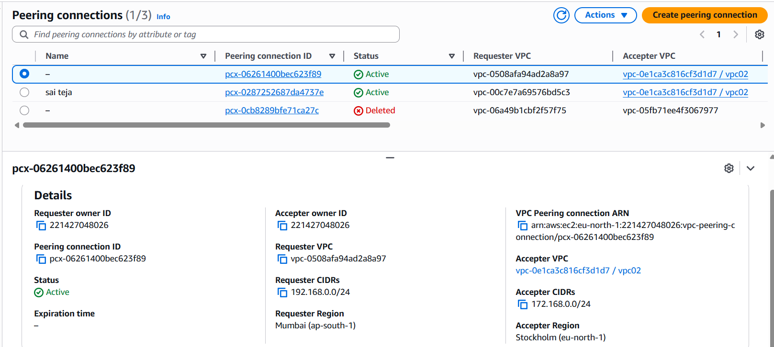
- created security groups in both regions and configured
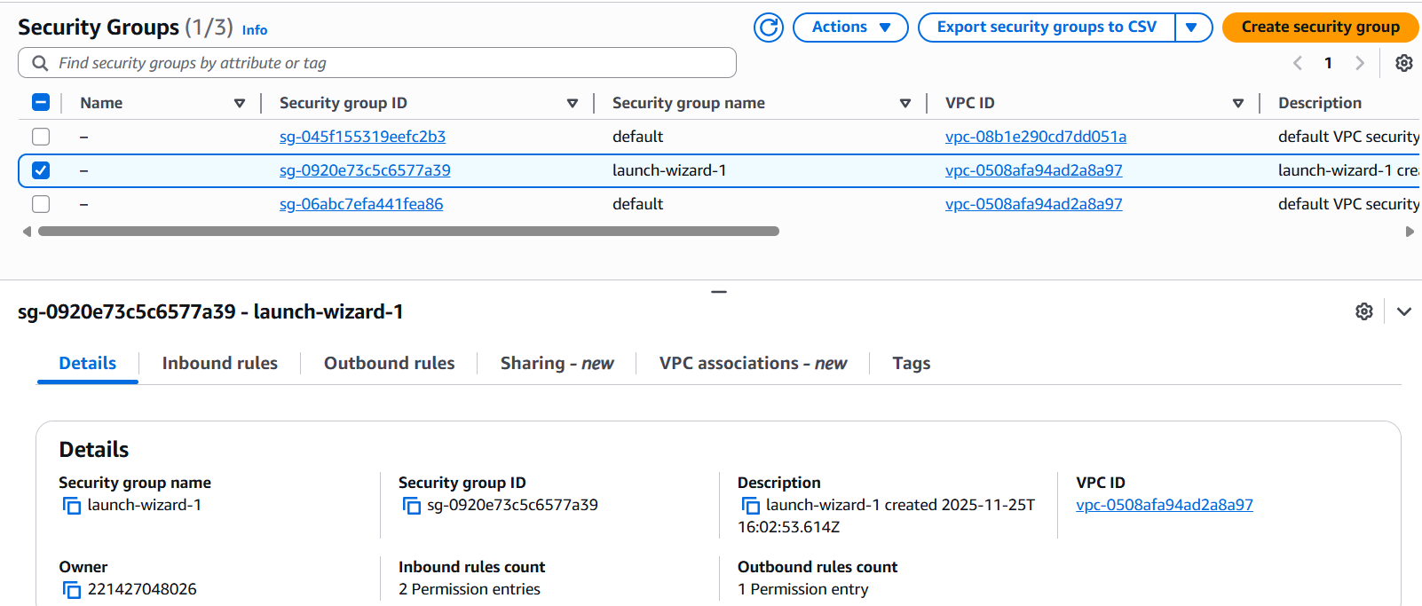
- launched ec2 instance named it ec201 in region A
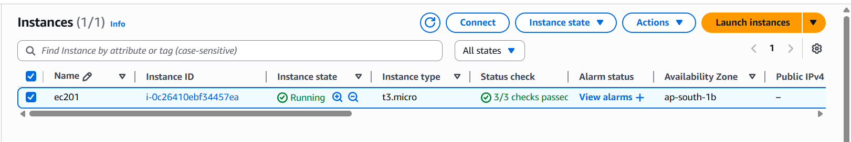
- launched ec2 instance named it myec202 in region B
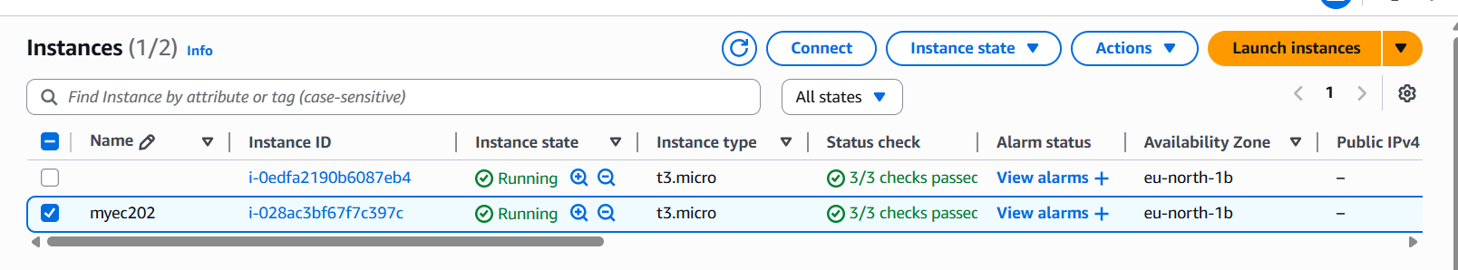
- now, copy ssh link from region A ec2 by connecting it. And test it in gitbash. To check region B cat private key and copy it
- use command vi test.pem and paste private key here and change permissions chmod 600 test.pem > sudo su and using private Id us eping 172.168.0.8.
- it is running successfully as we can see in the below screenshot.
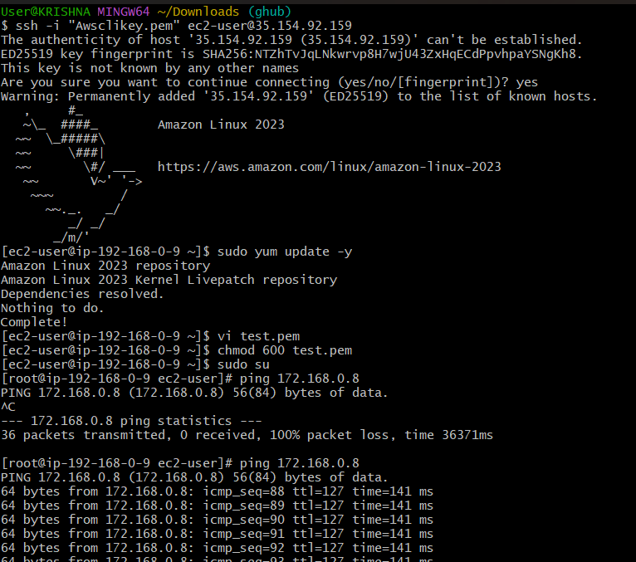

- Enable VPC peering for cross-account (you can collaborate with your friend to do this task).
- Create an peering connection > give an name > give vpc Id (Requester) > select Another account in vpc to peer with and enter receiver account Id, region and vpc Id > click on create peering connection.
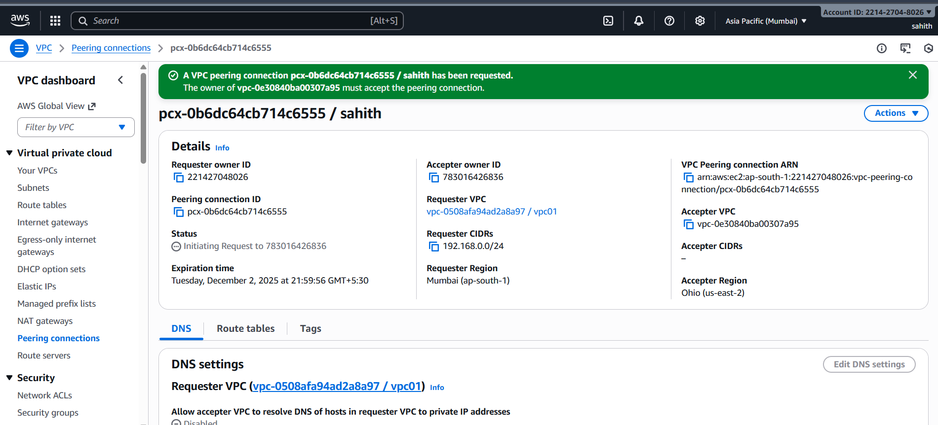
- Once receiver accepted the request config the route table by adding cidr range.
- Using receiver private Id check whether it is working or not using command ping 192.168.1.0
- Now it is working as we can see in the screenshot

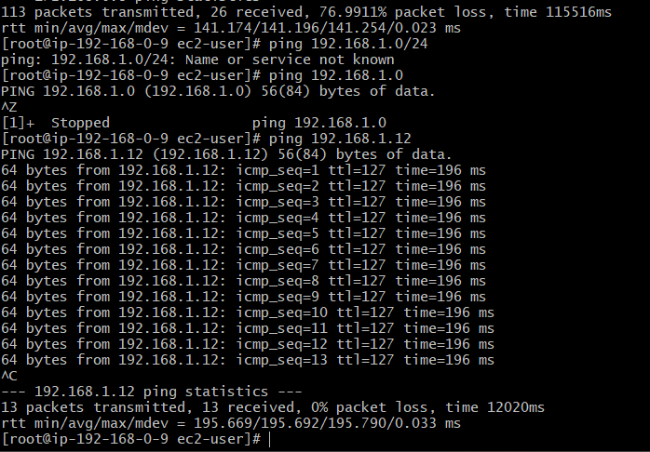
- Set up a VPC Transit Gateway.
- Created three vpc’s
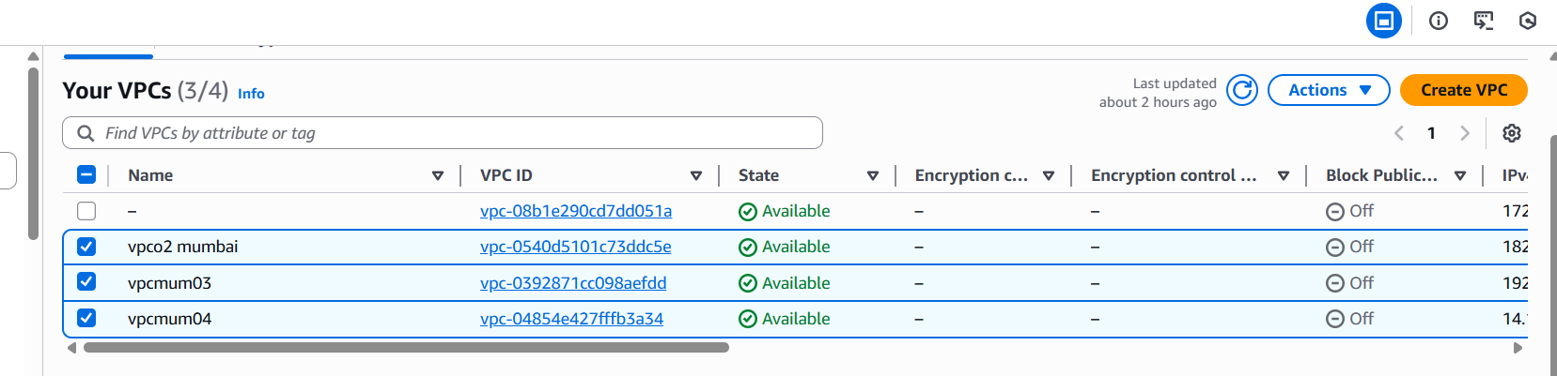
- Created three subnets
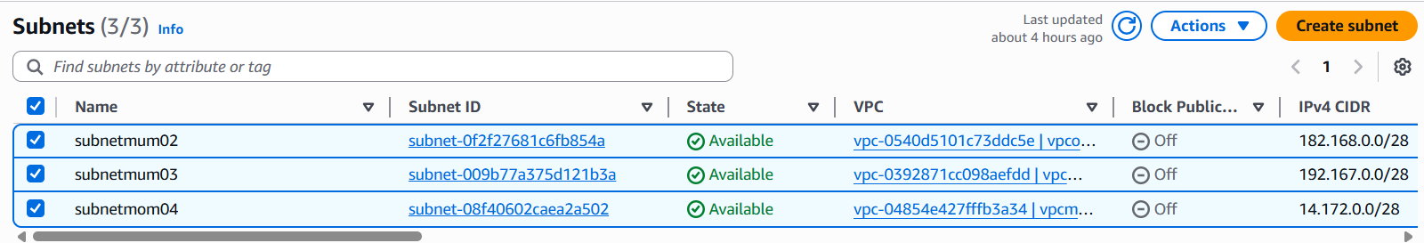
- Route three tables and config subnet associations
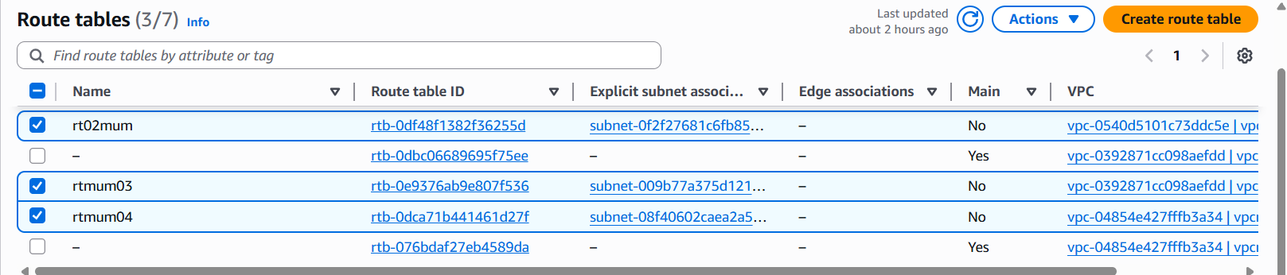
- Created three separate gateways and configured to respective route tables
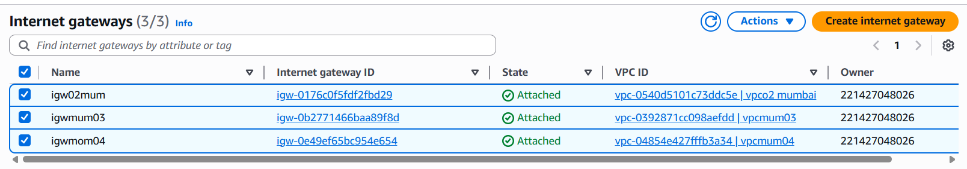
- Created one transit gateway
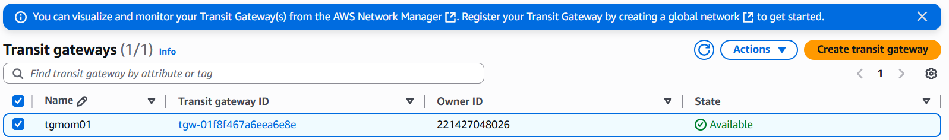
- Using transit gateway Id create three different transit gateway attachments to vpc’s
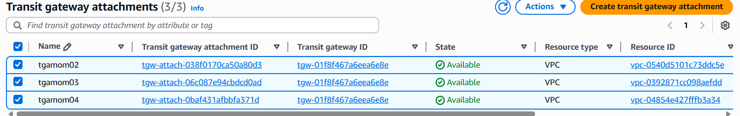
- In the route tables > edit routes > here add vpc Ip address and their transit gateway id of other two vpc’s and repeat same for remains other vpc route tables.
- Configure all the security groups
- Cidr can’t be same, it should be different for very vpc
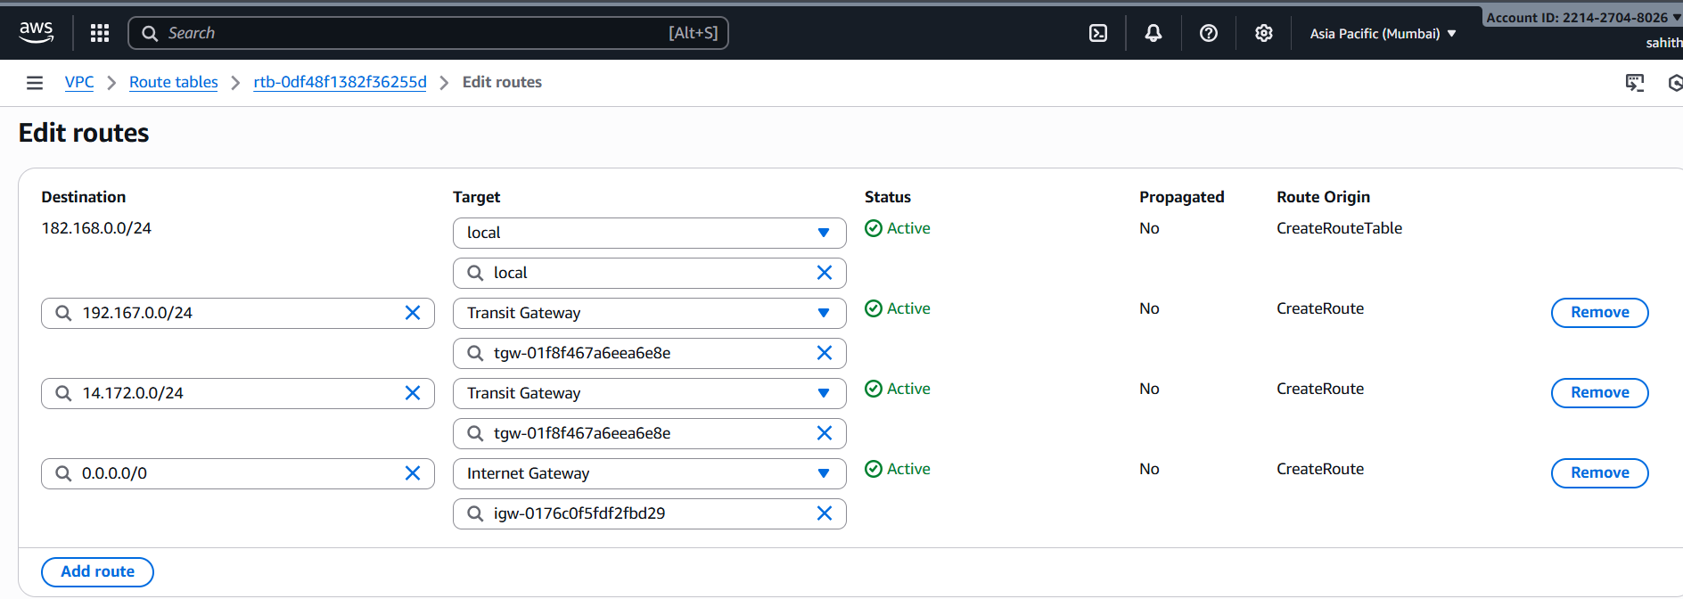
- Launched three ec2 instances for different vpc’s.
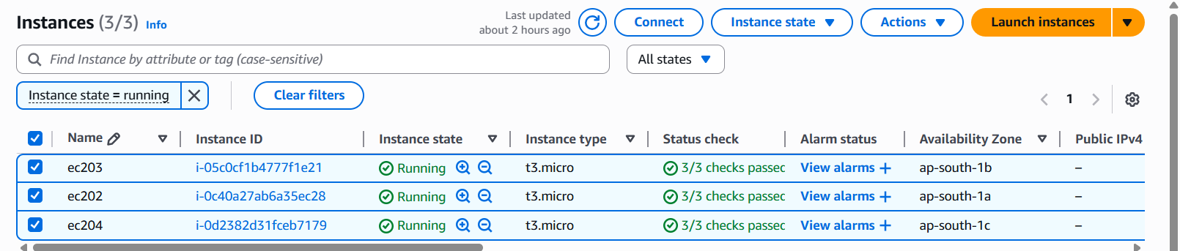
- Now, launch ec202 instance and connect. use ping (use second vpc Ip address here) enter, we can see it is running successfully
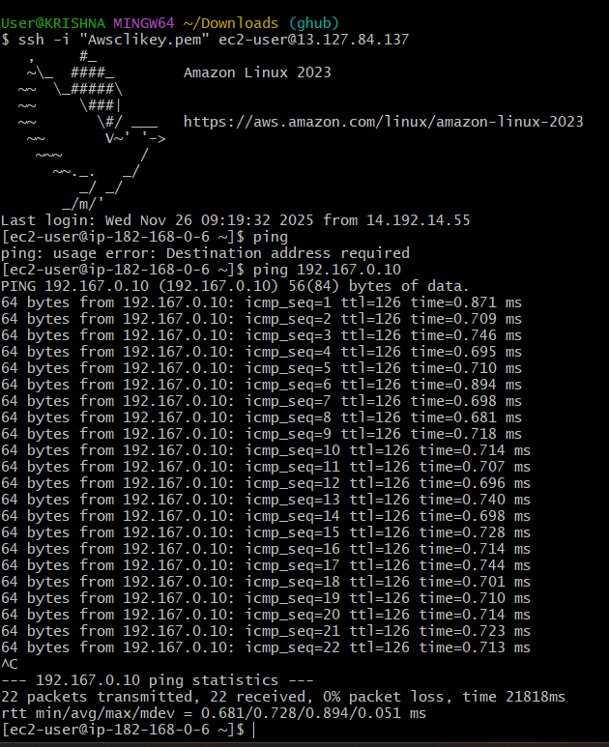
- Now, launch ec203 instance and connect. use ping (use third vpc Ip address here) enter, we can see it is running successfully
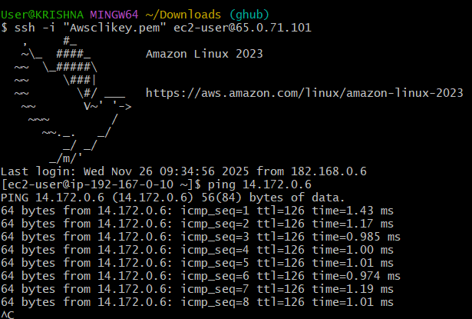
- Now, launch ec204 instance and connect. use ping (use first vpc Ip address here) enter, we can see it is running successfully.
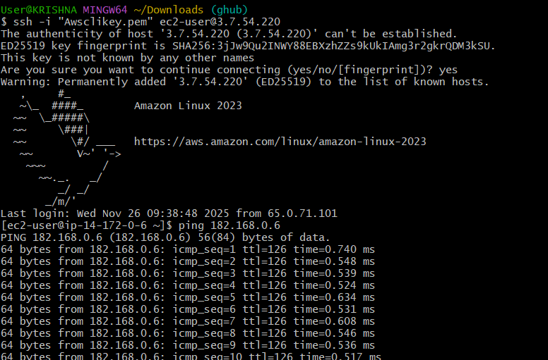
- Set up a VPC Endpoint.
- Created two instances one public and one for private and launched public instances
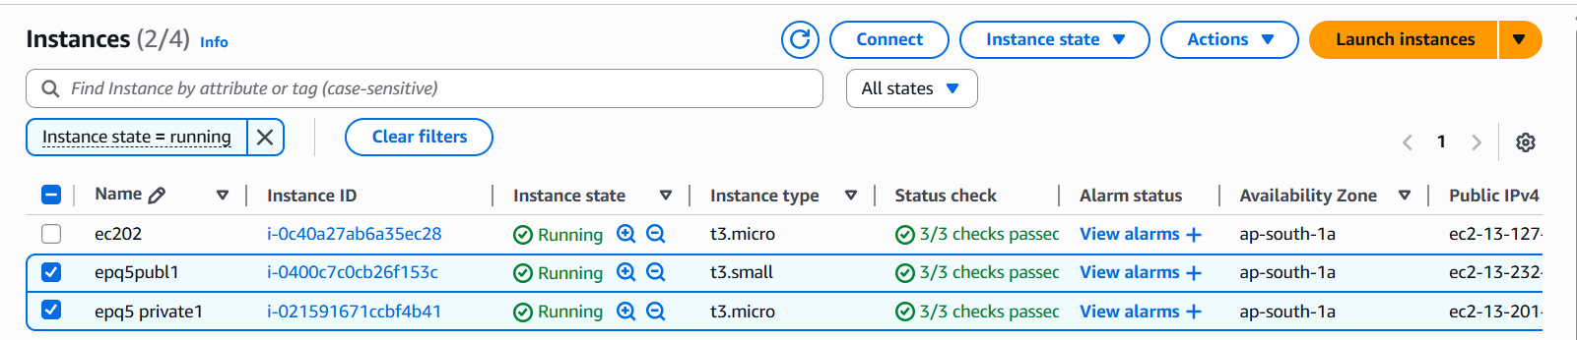
- Using aws configure, configured newly created access key, secret access.
- Create an new file copy paste the pem key here, give permissions and execute.
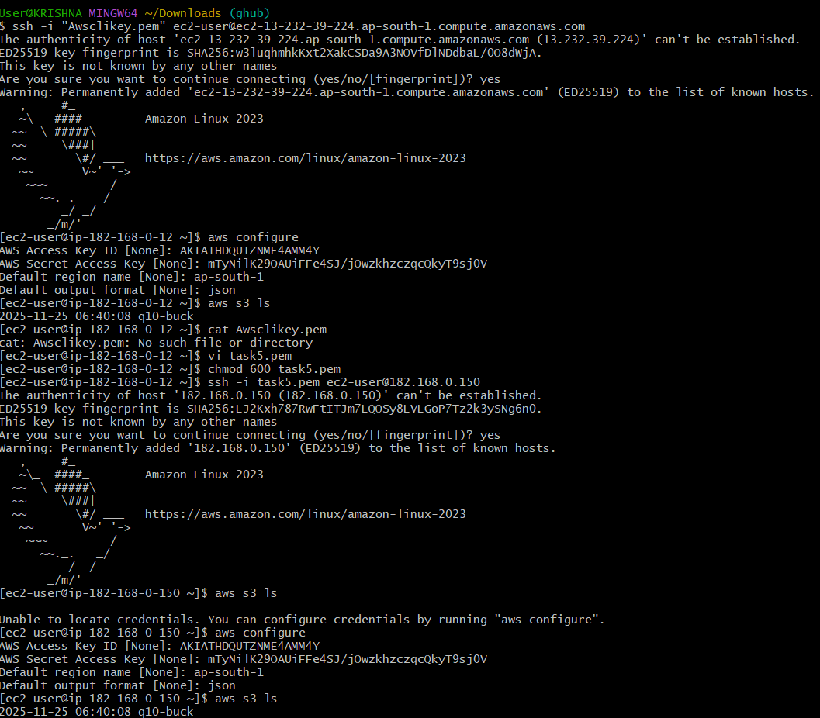
- Select end points > gave name endpointq5 > type Aws services > in service search for s3 and select. > select vpc in network settings > Additional settings select enable private DNS name > select subnets > select default security groups > In policy select full access > click on create endpoint.
- if it shows available in status then it is created successfully.
